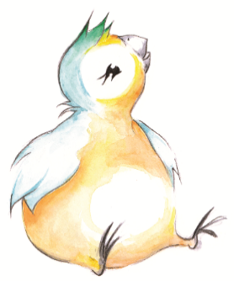





Peep Group Agreement to adapt
- Confidentiality – what is shared stays in the room, except if we are worried that you or someone else is at risk
- Phones away and on silent or vibrate
- We will try and stick to start and end times
- We’re all responsible for our own children
- Respect and support each other – there’s no such thing as a silly question or answer
- We will model listening to the story
- Share ideas and have fun!

www.peeple.org.uk

@PeepleCentre
If we have any concerns about the safety of you or your child we have a legal duty to pass on our worries to someone who can help. We will not ask your permission if we are worried, but will always tell you what we have done, unless doing so would cause further risk. Our safeguarding policy can be found on our website at www.peeple.org.uk or you can contact the office to ask for a copy.

