



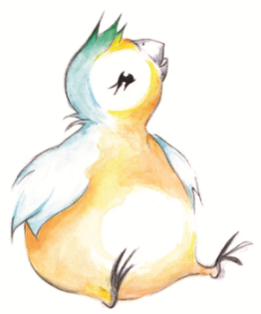

Outdoor Group Agreement

- If you or your child is unwell prior to the session do not attend the group, if unwell after the group please inform the practitioners immediately.

- Wear weather appropriate clothes, bring wipes/hand-sanitiser and a rug for your family to sit on.
- Maintain social distancing.
- You are responsible for your child(ren) at all times.
- Try to be on time. If you cannot attend the session please let the practitioner know, so the place can be offered to another family.
- Respect and be kind to each other.
- Peep practitioners will take pictures of the group throughout the sessions, but will only share them if you have agreed via your completed photo/video consent form.
- Only take photos of your own children.

Most importantly - have fun!
www.peeple.org.uk

@PeepleCentre
If we have any concerns about the safety of you or your child, we have a legal duty to pass on our worries to someone who can help. We will not ask your permission if we are worried, but will always tell you what we have done, unless doing so would cause further risk. Our safeguarding policy can be found on our website at www.peeple.org.uk or you can contact the office to ask for a copy.

