Who for: Peep LTP Training is for practitioners who (plan to) work with parents/ carers and babies/ young children, to contribute to:  - strong parent-child relationships,  - increased parental knowledge and confidence in how to support their child's learning and play in day-to-day life,  - children’s personal, social & emotional development, communication & language, early literacy, early maths, and health & physical development.  Aims: The training equips practitioners to:  - engage and support parents to build on what they already do to enhance their baby's or child's early learning and communication (contributing to school-readiness), through talking and playing as part of everyday life,  - explore practical ideas, strategies and resources, using the comprehensive and flexible Peep Learning Together Programme,  - deliver universal or targeted sessions with parents and children together – in person or online: 1-to-1, groups or drop-ins. | 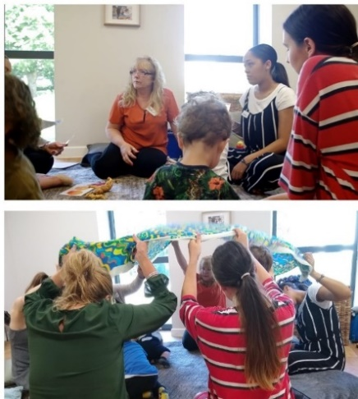
Online video-call platform: We prefer Zoom for its useability (read more) but contact us if you can only use Microsoft Teams.
Prior experience or software not necessary.
Device: Delegates should each have a laptop/ computer (or tablet) to use, at home or at work; if this is a problem please let us know in advance.
Please book at least 5 working days before the course starts to ensure the training pack reaches each delegate in the post before the course.
Duration: Usually four sessions of 3 hours each, over two consecutive full days or four half-days. Delegates need to attend all sessions.
Training price: £395* + vat per person, including online access to the whole LTP, with downloadable child development topics, session plans, handouts etc. (*Price increasing to £425 + vat pp from 1 July – book before then and attend up to end of September)
[Trained practitioners can opt to buy a Programme Folder containing all the topics and/or songbooks/CDs/MP3s etc: www.peeple.org.uk/shop]
No. of delegates/ online course: Approx. 10 - 12 Course dates: see www.peeple.org.uk/dates, or contact us to discuss your own course.
Online training Feedback:  'Excellent course, worked very well online. Information was clear, with plenty of time for questions & conversation about the content.'  Family Support worker, Oxfordshire | ‘I thoroughly enjoyed the course and wasn’t really expecting to as it was online. I think Peep is a wonderfully flexible, accessible resource which can be used to develop what we already do as practitioners and what parents do every day.' Family Support worker, County Fermanagh | Post-course feedback: 'Peep is inclusive and doesn't preach to parents, making it more accessible. Parents appreciate that the activities are easy to do and they don't need to go and buy expensive resources.’  Nursery nurse, West Lothian
Any questions – please email: training@peeple.org.uk or tel 01865 397970 / Booking form overleaf

Please use a different form for each course | Course dates for this booking form:

Please complete all fields and return this form at least 5 working days before the training (ideally 2 weeks for multiple places) so the training pack(s) arrives in time. Please let delegates know where their pack will be sent. Add more rows as applicable.
Delegate Name: | Delegate main Email for training invitations etc – please check with delegates | 2nd work email (if you have 2/ if bouncebacks) | Delegate Job title: | Delegate mobile no. (to resolve any issues): | Delegate Address (work or home - for training pack to be posted to):

Contact/ Organiser details:
Contact Name: |  |  | Job title: |  | Tel:
Email: |  |  | Organisation name: |  | Organisation Address:
Delegates’ Managers’ Email(s) for delivery support (if different to Contact above): |  |  |  |  | Delegates’ Managers’ Name(s):

Details to appear on the Invoice:
Invoice contact name: |  | Email (to invoice): |  | Tel:
Organisation name/ dept: |  | Address (to appear on the invoice):
Purchase order no. or code (if applicable): |  | No. of delegates: |  | Total £ excl. vat:

Please return this form to: training@peeple.org.uk Tel: 01865 397970
Payment and Cancellation Terms and Conditions: (Peep Learning Ltd Vat Registration no: 768 4173 94) Peep Learning Ltd, the trading arm of Peeple, will invoice you after receiving this booking form. Payment is due within 30 days of invoice date. Fees are only refundable if cancelled more than two weeks before the course.
GDPR: Peeple holds customers’ contact details on our secure training database for the purpose of booking course places and sending out relevant pre- and post-course information (see www.peeple.org.uk/privacy-policy for further info). v2.7 (5.22)

