Who for: Peep LTP Training is for practitioners who work with parents/ carers and babies/ young children, to contribute to:  - strong parent-child relationships,  - increased parental knowledge and confidence in how to support their child's learning and play in day-to-day life,  - children’s personal, social & emotional development, communication & language, early literacy, early maths, and health & physical development.  Aims: The training equips practitioners to:  - engage and support parents to build on what they already do to enhance their baby's or child's early learning and communication (contributing to school-readiness), through talking and playing as part of everyday life,  - explore practical ideas, strategies and resources, using the comprehensive and flexible Peep Learning Together Programme,  - deliver universal or targeted sessions with parents and children together – in person or online: 1-to-1, groups or drop-ins. | 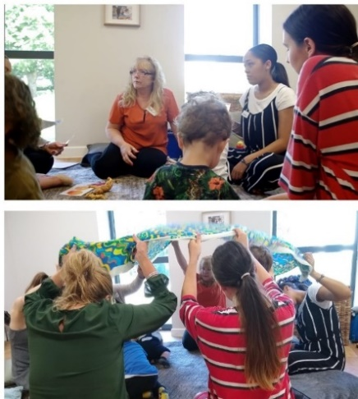

Duration: Two consecutive days: 9.30 - 4.30pm No. of delegates/ course: Approx. 10 – 12 online, or 14 – 20 delegates face-to-face
How delivered: Face-to-face or online. If online: We prefer Teams for its useability but let us know if you can only use another platform. Prior experience or software not necessary. Delegates should each have a laptop/ computer (or tablet) to use, at home or at work; if this is a problem please let us know in advance.
Training price*: £425 + vat per person, including online access to the whole LTP, with downloadable child development topics, session plans, handouts etc and post-course delivery support. Optional extra: Practitioner accreditation unit (3 credits) [£40 + vat pp, including downloadable portfolio, support sessions, and certification]
* Please note – training prices from 1 April 2024: the price will increase to £450 + vat pp, or £500 + vat pp including the Practitioner Accreditation unit. If not booked at the same time as the training, the Practitioner Accreditation unit price will increase from the introductory price of £40 pp to £70 pp.
[Trained practitioners can opt to buy a Programme Folder containing all the topics and/or songbooks/CDs/MP3s etc: www.peeple.org.uk/shop]
Course dates: see www.peeple.org.uk/dates, or contact us to discuss holding your own course.
Please book and send delegate details at least 14 days before the course starts.
Training Feedback:  'Excellent course, worked very well online. Information was clear, with plenty of time for questions & conversation about the content.'  Family Support worker, Oxfordshire | ‘I thoroughly enjoyed the course and wasn’t really expecting to as it was online. I think Peep is a wonderfully flexible, accessible resource which can be used to develop what we already do as practitioners and what parents do every day.' Family Support worker, County Fermanagh | Post-course feedback: 'Peep is inclusive and doesn't preach to parents, making it more accessible. Parents appreciate that the activities are easy to do and they don't need to go and buy expensive resources.’  Nursery nurse, West Lothian
Any questions – please email: training@peeple.org.uk or tel 01865 397970 / Booking form overleaf

Please use a different form for each course | Course dates for this booking form:

Please complete all fields and return this form at least 14 days before the training. Contact us if booking more than 3 places.
If online training: Please let delegates know where their pack will be sent, and check their preferred email and tel no.
Delegate Name (as to be displayed on certificate): | Delegate Email for training invitations etc (incl. second work email if you use two): | Delegate Job title: | Delegate mobile no. (if online, to resolve any tech issues): | Delegate Address IF ONLINE: (work or home - for training pack to be posted to): | Manager’s Email:
Please let us know via email if you have any individual learning needs so that we can support you as necessary
Contact/ Organiser details (if booking on behalf of colleagues):
Contact Name: |  |  | Job title: |  |  | Tel: |  | Email:
Organisation name: |  |  | Organisation Address: |  |  |  |  | City/County:

Details to appear on the Invoice:
Contact name: |  |  | Email (for invoice): |  |  | Tel:
Organisation name/ dept: |  |  | Address (to appear on the invoice):
Purchase order number (or say if N/A or waiting for no.): |  |  |  | No. of delegates: |  | Total £ excl. vat:

How did you hear about this course?
Please return this form to: training@peeple.org.uk Tel: 01865 397970
Payment and Cancellation Terms and Conditions: Peep Learning Ltd, the trading arm of Peeple, will invoice you after receiving this booking form. Payment is due within 30 days of invoice date. Fees are only refundable if cancelled more than two weeks before the course. (Peep Learning Ltd Vat Registration no: 768 4173 94)
GDPR: Peeple holds customers’ contact details on our secure training database for the purpose of booking course places and sending out relevant pre- and post-course information (see www.peeple.org.uk/privacy-policy for further info).

